



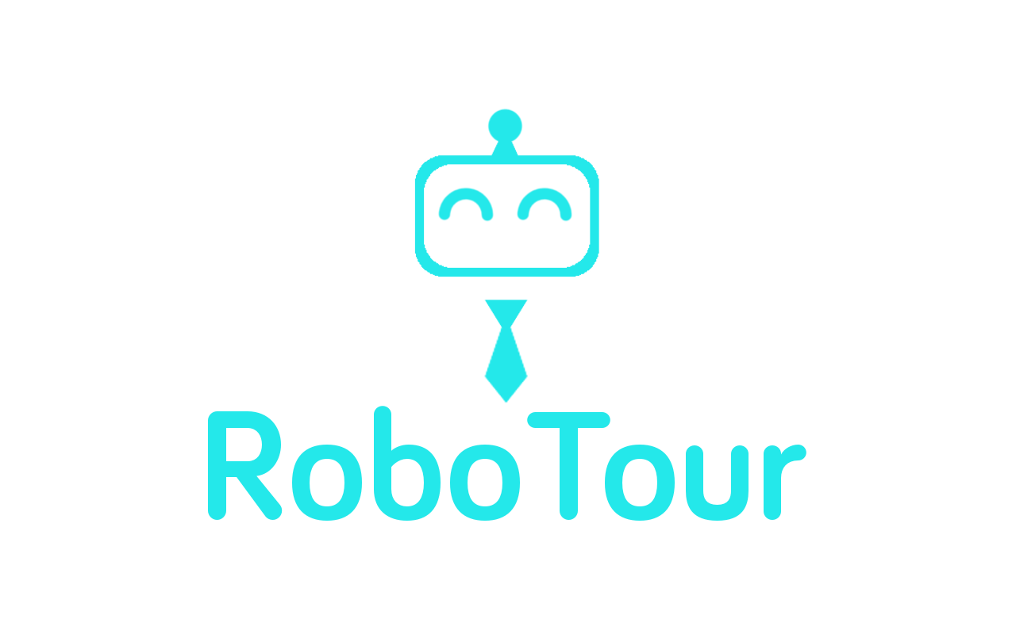

**Group 18**

Mariyana Cholakova

Michal Dauenhauer

Mahbub Iftekhar

Deividas Lavrik

David Speers

Alice Wu

Finn Zhan Chen

**1.0 Introduction** **2**

**2.0 Concept and Goals** **2**

2.1 RoboTour Specification 2

2.2 User Interface 3

2.3 Marketing: Market, User & Solution 4

2.3.1 Target User 1 - Visitors with Language Barriers 4

2.3.2 Target User 2 - Visitors who require directional assistance 4

2.4 Physical Mockup 5

**3.0 Time Planning** **5**

3.1 Technical Milestones for Client Demo 5

3.1.1 Client Demo 1 - 07/02/2018 5

3.1.2 Client Demo 2 - 28/02/2018 6

3.1.3 Client Demo 3 - 14/03/2018 6

3.1.4 Final Client Demo - 05/04/2018 7

3.2 Resource Deployment (200 hours/member) 7

3.3 Team Strengths 7

3.4 Setting up demo environment 8

3.5 Delegation and Volunteering 8

**4.0 Dependencies and Risks** **8**

4.1 Gantt Chart 8

4.2 Prototype Constraints 9

4.3 Human Risks 9

4.3.1 Differing Opinions 9

4.3.2. Contingency planning 9

4.4 Technical Risks 9

4.4.1 Feasibility 9

4.4.2 Losing The Path 9

**5.0 Organisational Structure** **9**

5.1 Task Allocation 9

5.2 Meetings 10

5.3 Communications 10

5.4 Code/File-Sharing 10

5.5 Progress Monitoring/Tracking 10

5.6 Development Approach 10

**6 References** **11**

# 1.0 Introduction

Team RoboTour aims to develop a robotic tour guide system RoboTour that will assist people in environments such as museums or art galleries. This document describes the project plan and summary, outlining main features of the system, motivation behind it and the team’s general vision of the finished prototype. The plan focuses on processes and timelines that we will be used to develop the system, identifying relevant milestones, risks, and resources that are allocated to achieve the end goal.

# 2.0 Concept and Goals

RoboTour is a multi-purpose assistive robot tailored to museum visitors. RoboTour’s mission is to provide a dynamic cultural experience for visitors by increasing inclusivity through robot guiding assistance and elimination of language barriers.

In 2015 the UK had more than 200,000 Chinese tourists (The Guardian, 2016) and given that more than 99% of Chinese people do not speak any English (The Telegraph, 2017) we believe that the vast majority of Chinese tourists in the UK could benefit from RoboTour and this number is growing annually (Fig 1). However, RoboTour also provides support for other languages such as French, German and Spanish and so could be implemented in any country whose main language is one of those supported.

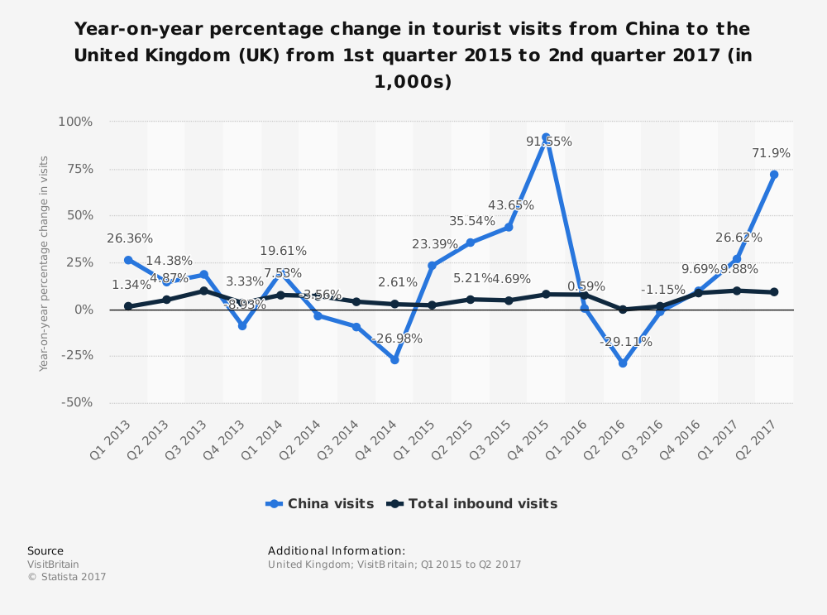

**Fig 1**: Growth in Chinese visitors to the UK (Visit Britain, 2017)

## 2.1 RoboTour Specification

RoboTour provides 4 key features to enhance the user’s experience, it:

1. Has multi-language support in Human-Robot Interaction via speech and app
2. Guides visitors to a specific art piece and points it out to the user
3. Plays audio description of art pieces in the language the user selected
4. Provides recommendations and optimal route planning routes

Our team plans to develop a prototype over 10 weeks. The prototype will be a scaled down version of the final system, yet demonstrating core functionality (subject to constraints in 4.2):

* The robot shall be able to navigate to a specific location using a system of branching lines on the floor
* The user shall be able to interact with the robot using a smartphone application
* The robot shall avoid collisions with other objects in the test area
* The robot shall operate in a controlled, simplified environment
* The system shall provide relevant information on the mock exhibition pieces

Below (Fig 2) we have a diagram showing a general technical subsystem for our specification:

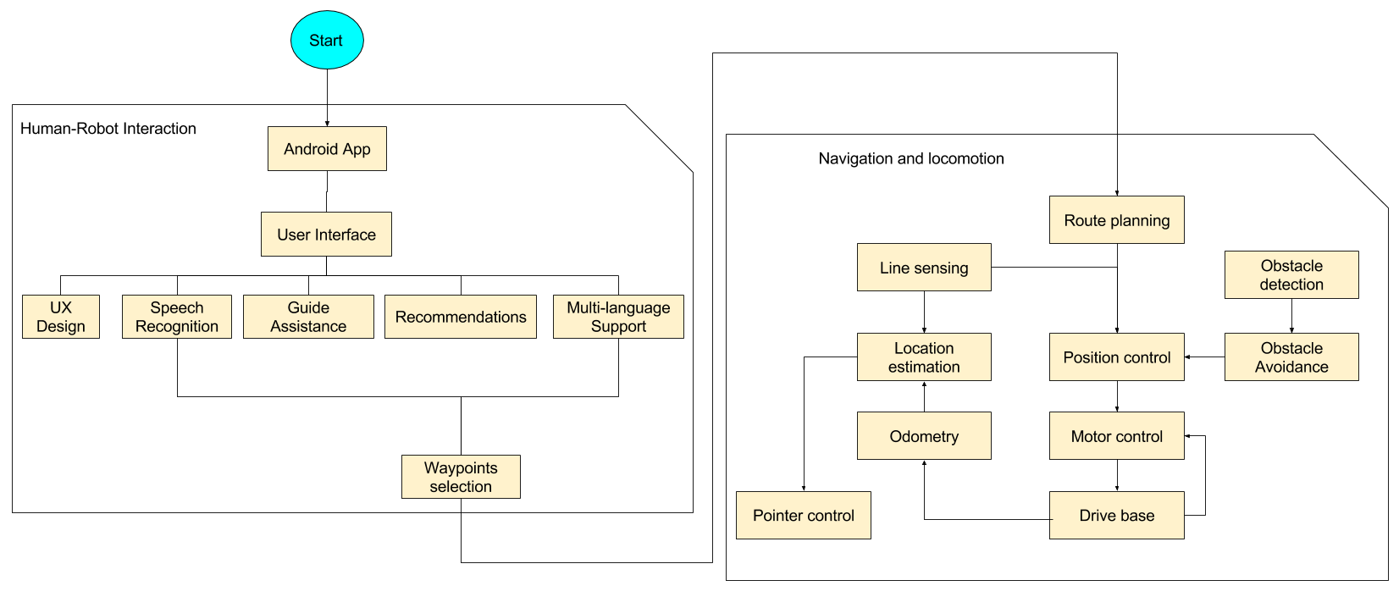

**Fig 2**: Technical system of RoboTour implementation

## 2.2 User Interface

Visitors can interact with the robot via an Android app via the touchscreen and voice input. The advantage of using an Android app is that most people would have a smartphone and existing speech recognition API from Google allows us to develop speech interaction between visitors and robots. The current version of our user Interface can be seen below in Fig 3.

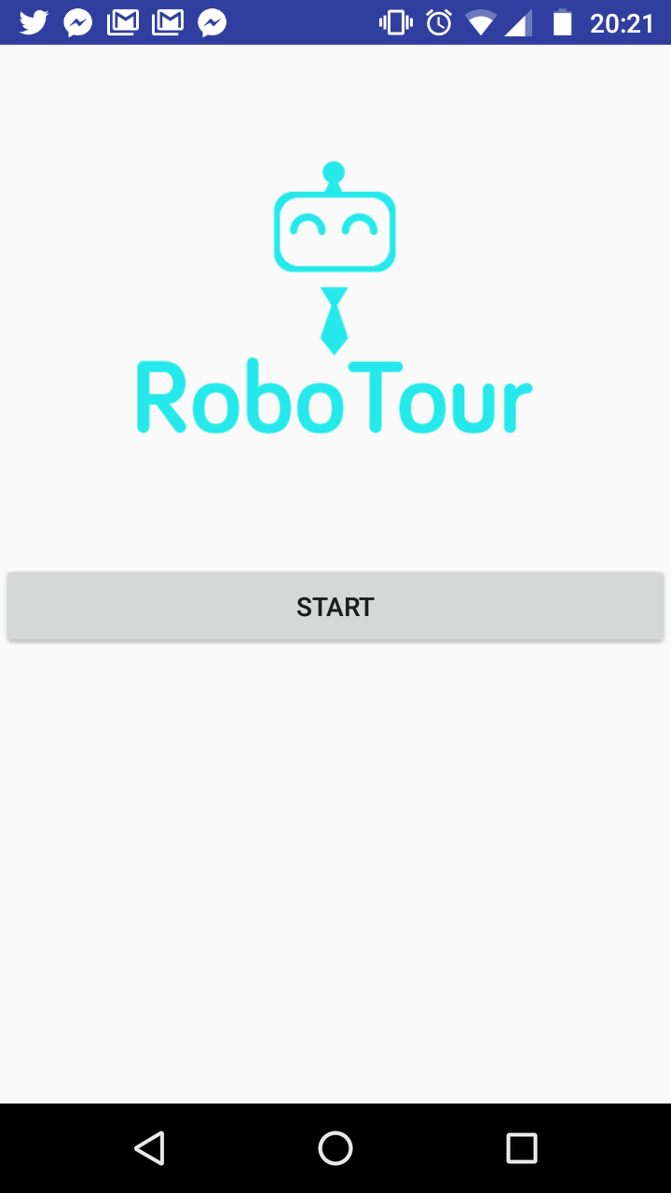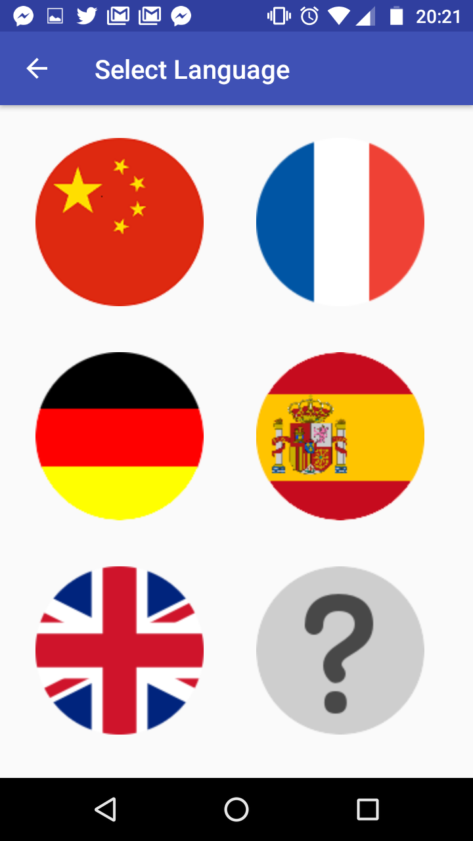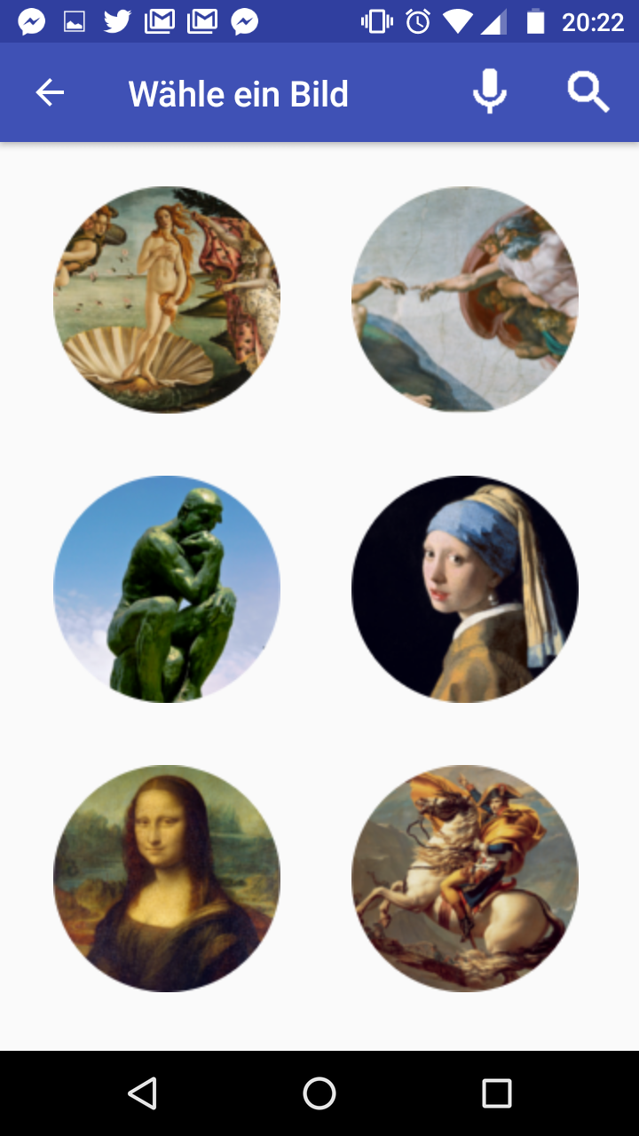

**Fig 3**: Our current user interface: Home Screen, Language Select, and Picture Selection respectively.

## 2.3 Marketing: Market, User & Solution

Beachhead strategy is adopted so RoboTour can concentrate on winning the market of one country before looking into other countries. UK museums are RoboTour’s beachhead market because of 2 key reasons: it is easier to carry out primary research, and our international team member’s personal experience with the user problems outlined next.

### 2.3.1 Target User 1 - Visitors with Language Barriers

**Problem:** UK museums have limited languages offering and are mostly dominated by English so visitors with no or limited fluency in the languages offered by museums are underserved, and thus cannot enjoy cultural immersion extensively.

**Evidence:** According to Fig 4, around 50% of annual museum visitors are from overseas. Based on primary observations at the museums of our team members, many of them come from countries where English is not the main language and many have limited or no English fluency.

**Solution:** RoboTour’s features 1 and 3 from section 2.1.

**Value Proposition - Revenue Increase:**

1. Better cultural immersion for overseas visitors
2. Attracts new overseas visitors with limited English fluency
3. Improved visitor experience and increased likelihood to spend

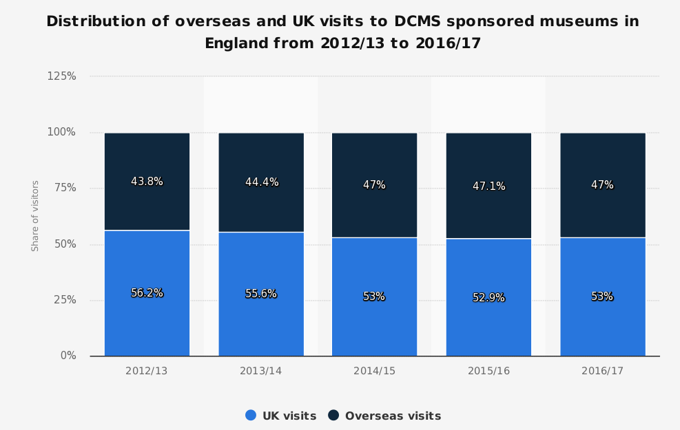

**Fig 4**: Distribution of overseas and UK visits to Museums in England (DCMS, 2018).

### 2.3.2 Target User 2 - Visitors who require directional assistance

**Problem**: Museums have to train and pay staff to help and guide visitors who require directional assistance, which can be very costly. Also, the system will be more scalable than staff, as the long term cost of an additional robot in the system will be lower than that of employing and training a new staff member.

**Evidence:** The People’s History Museum in Manchester said in its Business Plan that “Staff are the museum’s biggest resource, and biggest cost” (People’s History Museum, 2016). With RoboTour we will be able to reduce this staff cost by replacing most museum guides and assistants.

**Solution:** RoboTour’s feature 2 and 4 from section 2.1. RoboTour provides the user a personalized experience so they can efficiently visit the art pieces they wish to visit, optimizing the use of their scarce time.

**Value Proposition - Cost Reduction:**

1. Lower staffing cost in terms of headcount and training.
2. Lower time costs for visitors due to improved museum visitors traffic flow (optimal route planning)

## 2.4 Physical Mockup

The mockup of the prototype’s hardware setup is presented in Fig 5. The robot will feature a differential drive-base, a suite of environmental sensors and a motorized pointer to perform its designed actions.

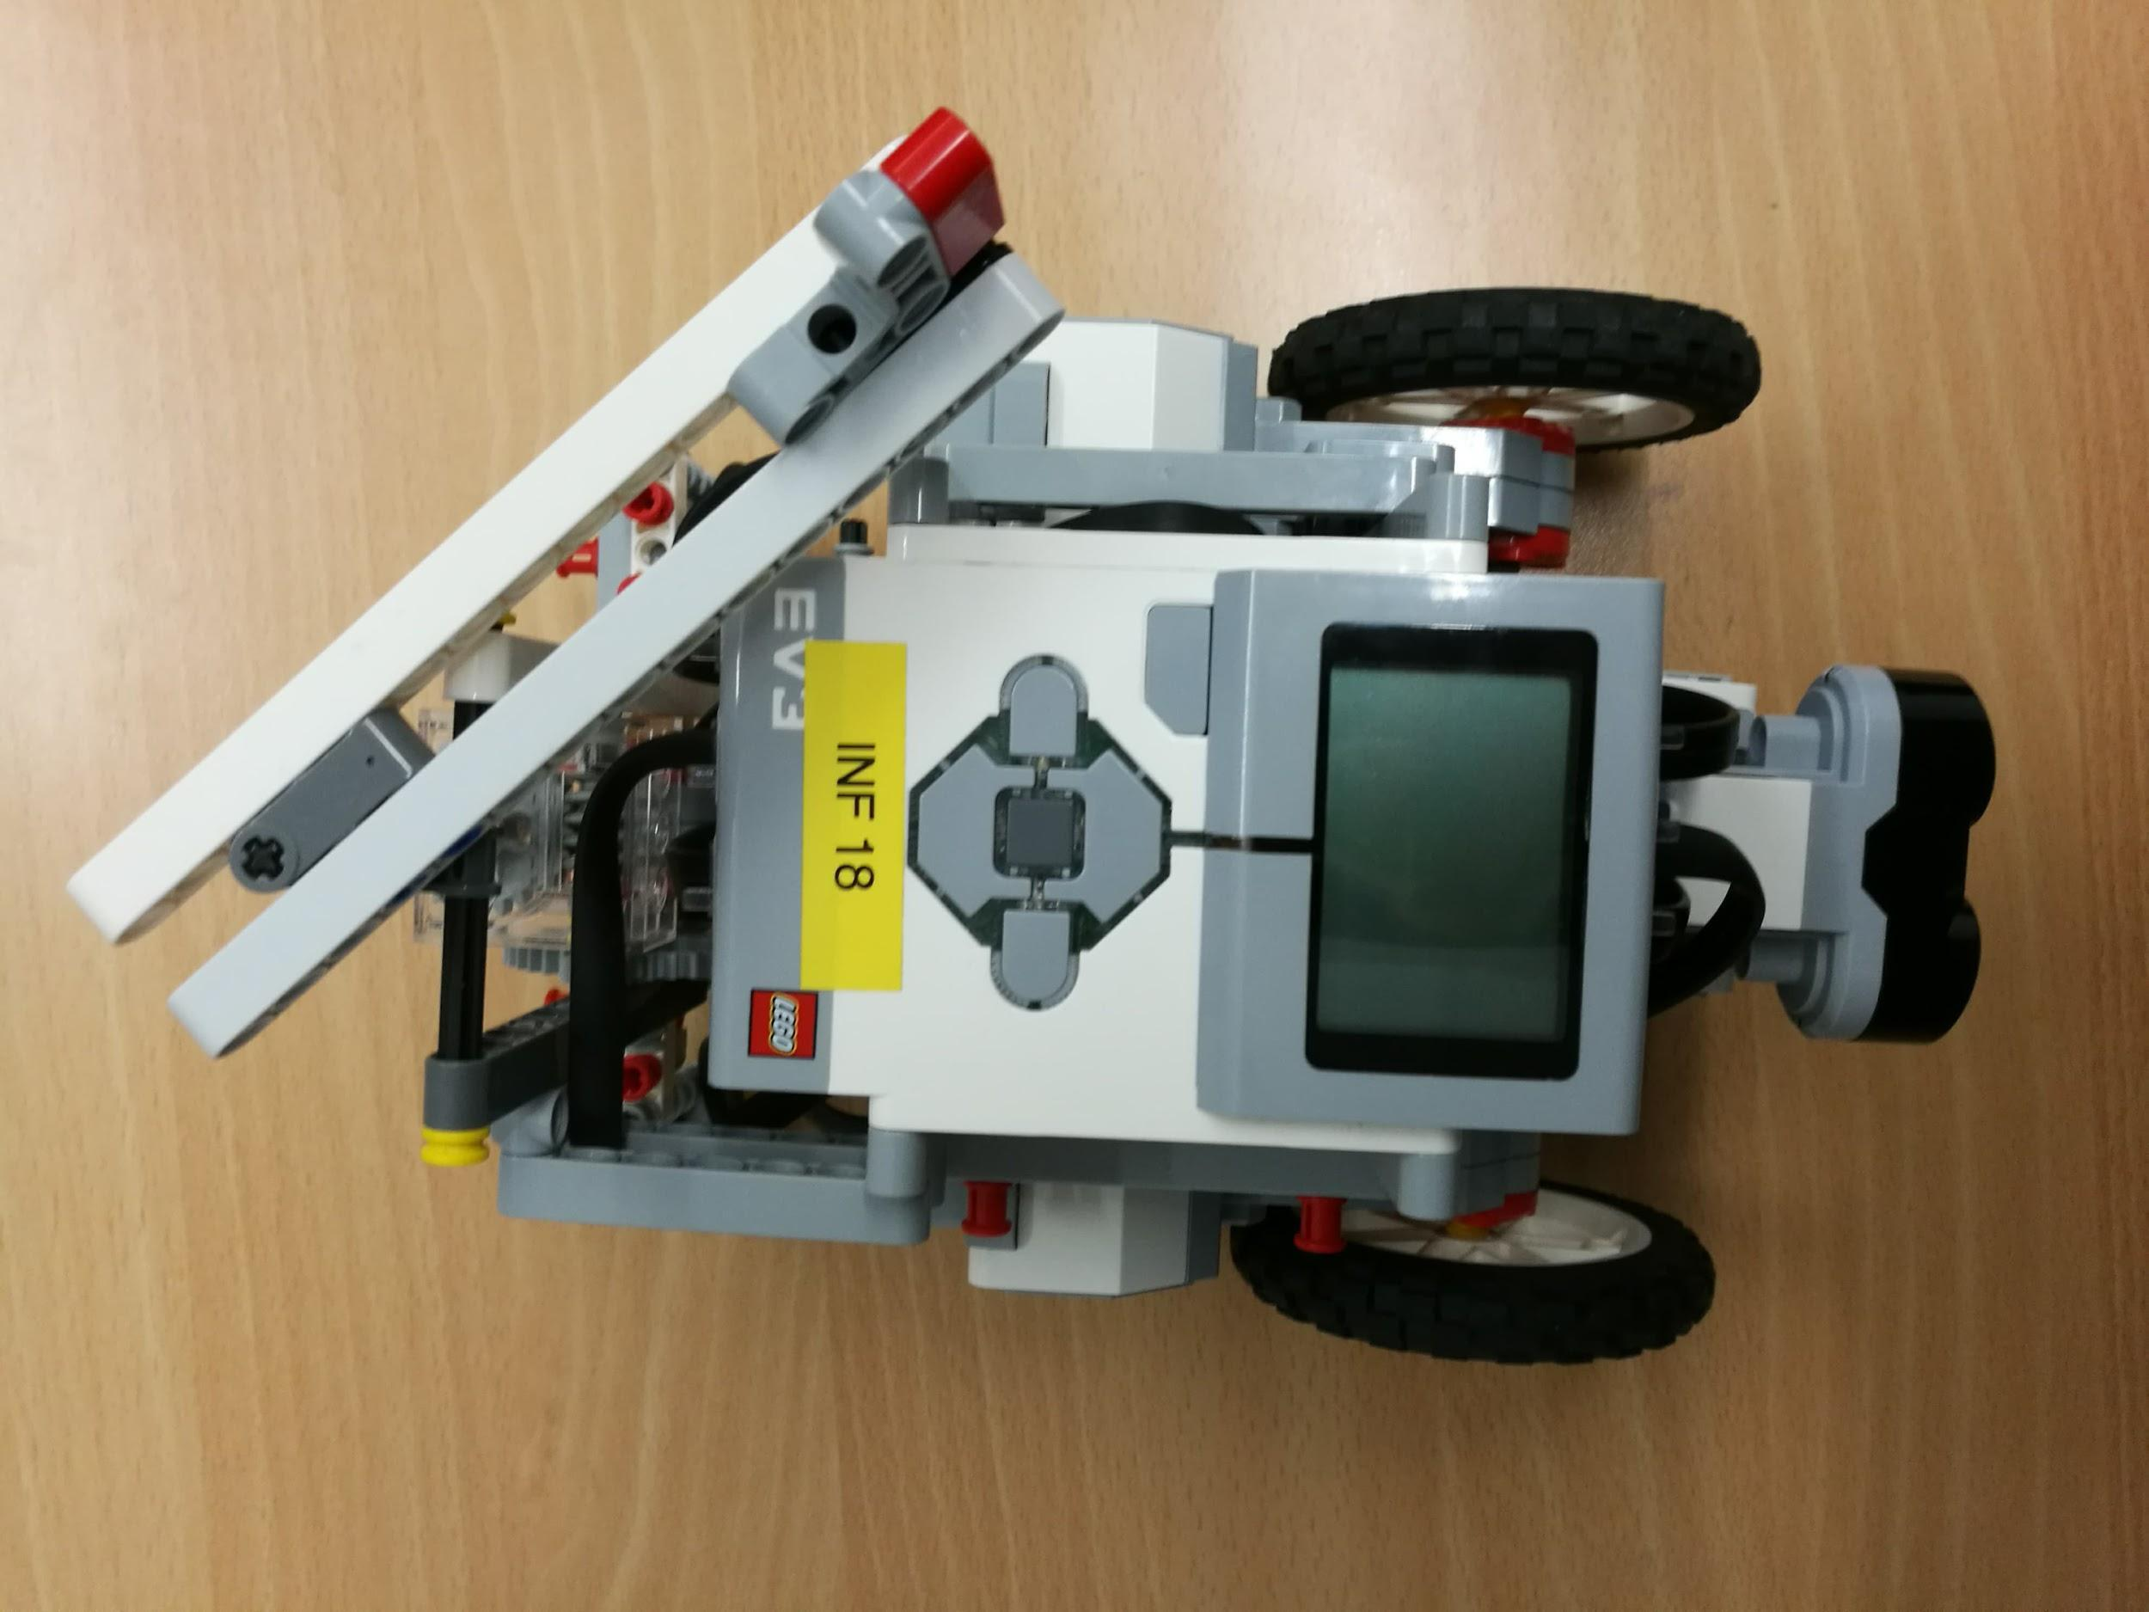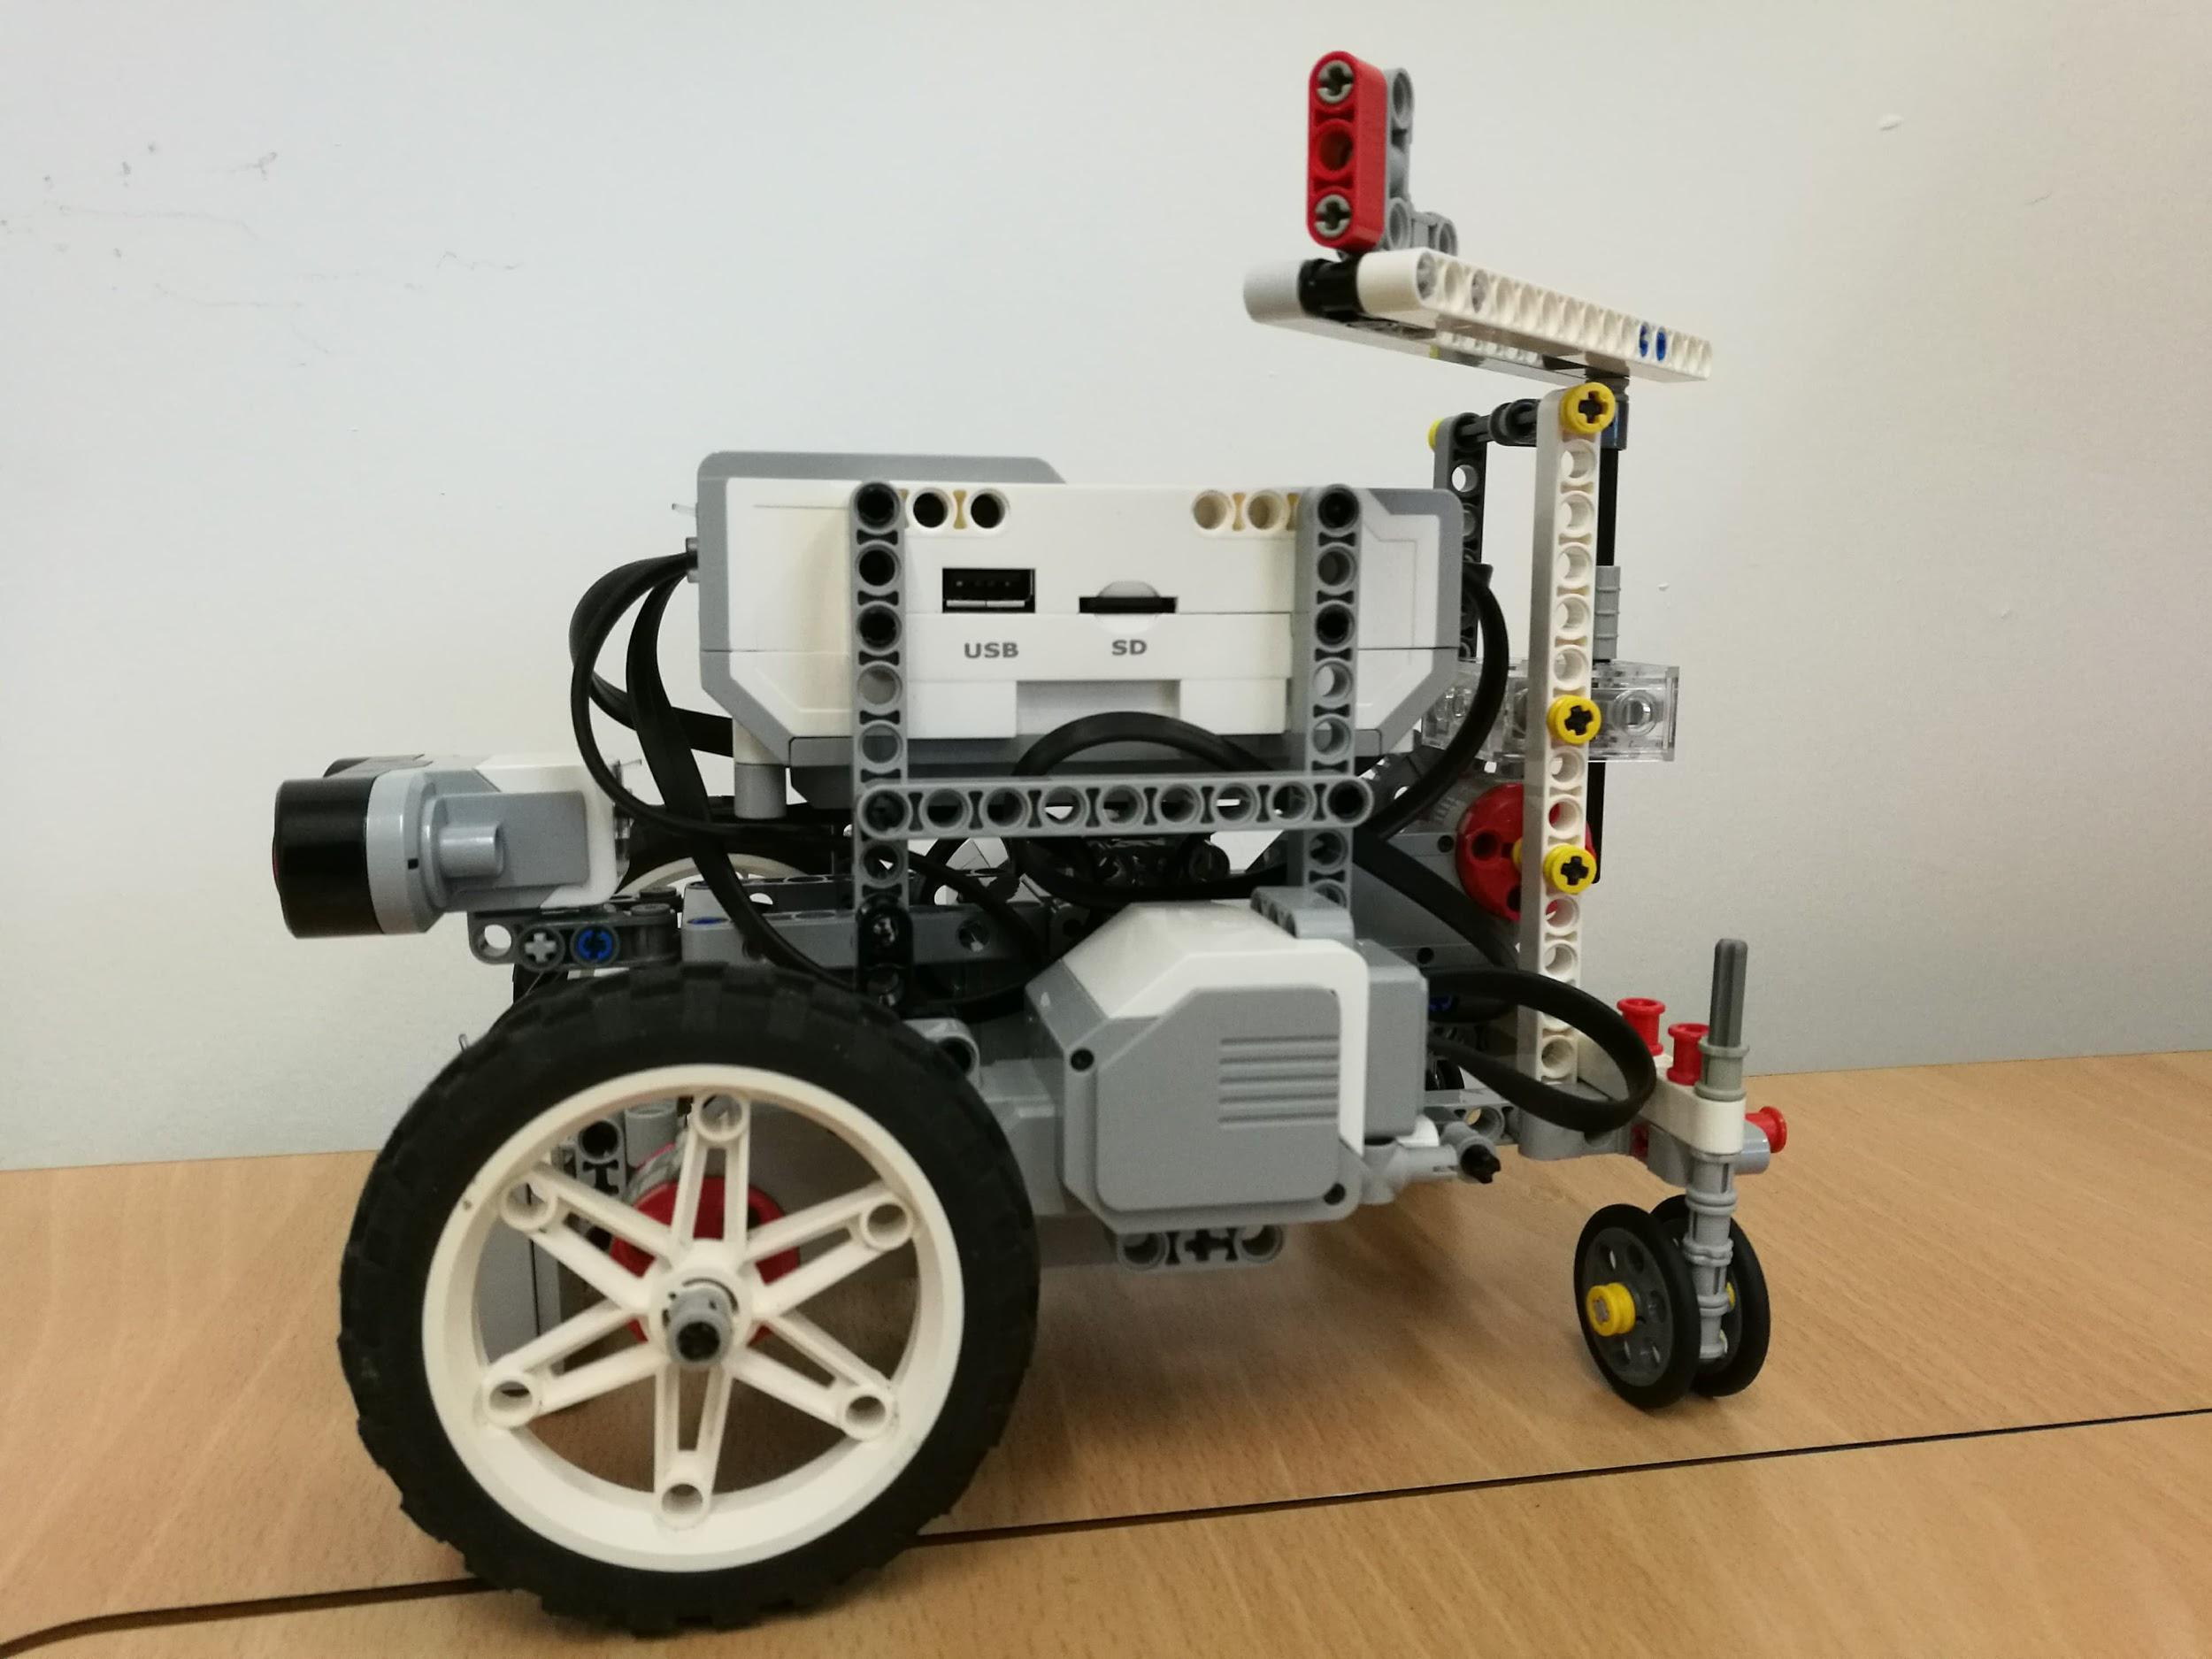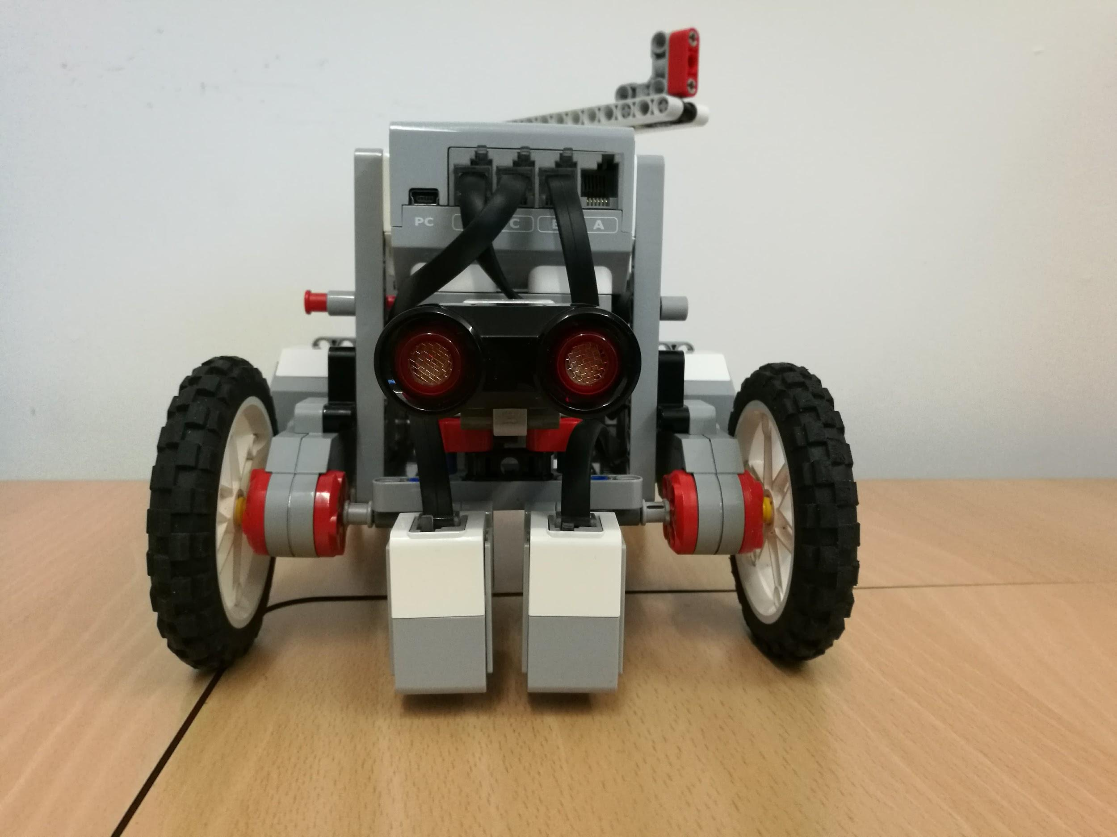

**Fig 5**: The current version of our robot. Top View, Side View, and Front View respectively.

# 3.0 Time Planning

## 3.1 Technical Milestones for Client Demo

### 3.1.1 Client Demo 1 - 07/02/2018

|  |  |
| --- | --- |
| **Technical Achievement** | **Evidence** |
| Basic robot built | The base robot is build featuring: ultrasonic sensors, 2 color sensors, 3 motors, 4 wheels (2 motorized and 2 for stability). |
| App-to-Robot communication | The robot can follow simple commands (i.e. move forward, move backward etc.) from the app. |
| User Interface completed | The user is able to interact with an image-driven application using the touchscreen. |
| Basic collision avoidance | The robot passively avoids collisions by stopping in front of detected objects. |

### 3.1.2 Client Demo 2 - 28/02/2018

|  |  |
| --- | --- |
| **Technical Achievement** | **Evidence** |
| Following line path | The robot can navigate simple branching line paths so that it reaches a predetermined destination. |
| Basic Speech Commands | The user can interact with the robot through the app via English speech. The user can send basic commands to the robot e.g. “Take me to X”. |
| Dynamic collision avoidance and navigation | If the preferred path is blocked, RoboTour re-plans to navigate around the obstacle (see Fig 6). |
| Motorised Robot Pointer | When RoboTour reaches an art piece, it points points to it. |

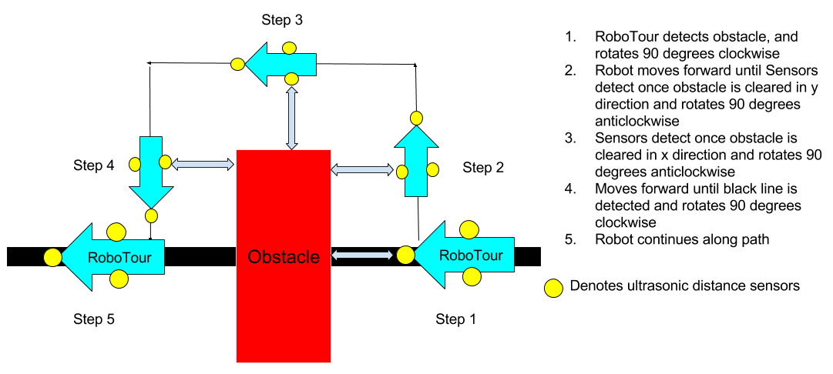

**Fig 6:** Obstacle avoidance strategy

### 

### 3.1.3 Client Demo 3 - 14/03/2018

|  |  |
| --- | --- |
| **Technical Achievement** | **Evidence** |
| Speed Adjustment / Variable Speed | The robot is able to adjust the speed to the users’ requirements. Additionally, the robot stops if the connection drops or upon the the users request. |
| Improved User Interface | Allows the user to ask the robot for recommendations via text or speech. There will be a script of acceptable speech commands. |
| Complex Path Planning | The robot considers multiple paths between selected points and selects the one that minimises travel time. |

### 3.1.4 Final Client Demo - 05/04/2018

|  |  |
| --- | --- |
| **Technical Achievement** | **Evidence** |
| Stability | The robot performs its tasks more reliably and consistently than in previous demonstrations. |
| Polish | Features from previous demos that needed polishing or enhancement are improved. Overall user experience is enhanced due to a better robot performance and better speech recognition. |

## 

## 3.2 Resource Deployment (200 hours/member)

Here is the detailed anticipated usage of the time per group member to achieve our goals.

We used Fig 7 to help us establish the Gantt chart in section 4.1.

**Fig 7**: Time allocation pie chart

## 3.3 Team Strengths

We have allocated tasks per team members based on their strengths - this is to enable us to use our resources efficiently.

**Key**

Limited (Red), Intermediate (Yellow), Advanced(Green)

|  |  |  |  |  |  |  |
| --- | --- | --- | --- | --- | --- | --- |
| **Name** | **Electronic Experience** | **OO**  **Programming** | **App**  **Development** | **Speech** | **Market Researching** | **Networks** |
| Michal |  |  |  |  |  |  |
| Mahbub |  |  |  |  |  |  |
| Alice |  |  |  |  |  |  |
| Finn |  |  |  |  |  |  |
| David |  |  |  |  |  |  |
| Mariyanna |  |  |  |  |  |  |
| Devidas |  |  |  |  |  |  |

## 3.4 Setting up demo environment

We plan to set up mock corridors using the existing layout at the back of the large lab as a demonstration area with minor modifications such as attaching mock artwork for the robot to navigate to using a single branching line on the floor using a single branching line on the floor We will place obstacles in the environment for RoboTour to navigate around.

## 3.5 Delegation and Volunteering

We have been allocating jobs on a skills basis. It is allowed for members to volunteer to do tasks they feel comfortable doing. If volunteers are not found the group leader will allocate roles based on the strengths of the team in order to optimally allocate resources.

# 4.0 Dependencies and Risks

## 4.1 Gantt Chart

There is a number of dependencies between the tasks. For example, building the robot is a dependency of environment sensing as the robot needs to have the sensors mounted to enable us to write reliable code for sensing the environment. All other dependencies refer to the fact that we cannot fully prepare for a demo until the required robot features are implemented. These dependencies are shown in the Gantt chart in Figure 8.

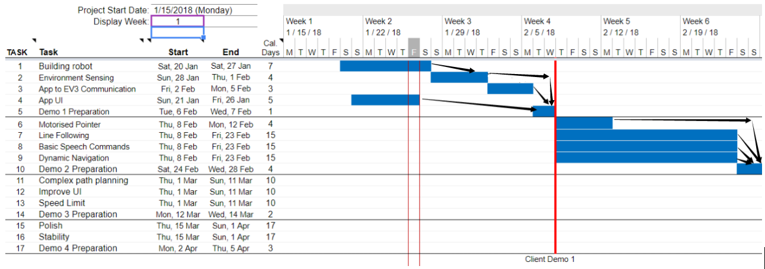

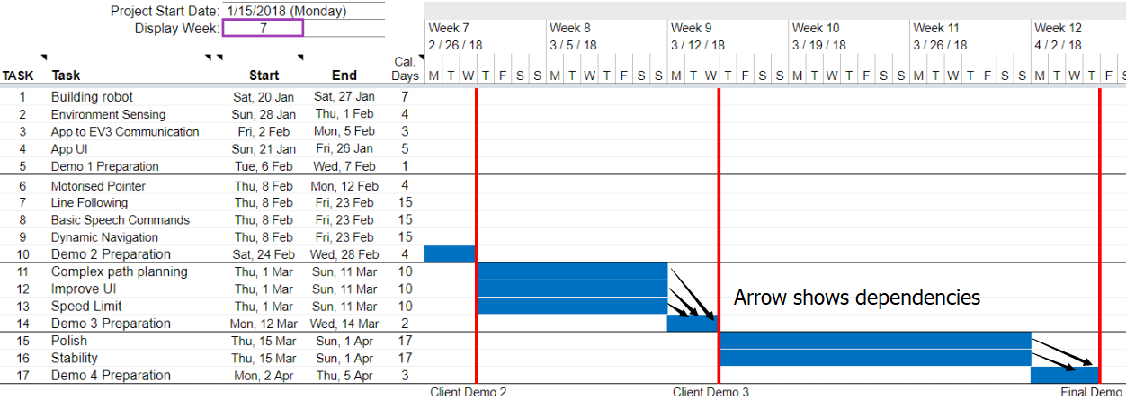

**Fig 8:** Project Gantt Chart with dependencies and client demos are identified in red

## 4.2 Prototype Constraints

* The prototype robot can only follow lines on the ground.
* It requires that the paintings locations do not change
* The robot will be smaller than the final product

## 4.3 Human Risks

### 4.3.1 Differing Opinions

Differing opinions will be decided by group voting. In cases where someone has a strong opinion about the direction of the project, they are encouraged to express their concerns and the team will reconsider the issue.

### 4.3.2. Contingency planning

Internal deadlines are set before the final deadline so that if something unplanned occurs we will have time to fix this. In cases where a team member has other priorities, they are encouraged to notify the team at least 1 week in advance so human resources are reallocated to make sure the deadlines are met. If anyone is ill, they are required to notify the team leader. Currently Mariyana is not in Edinburgh, but we are in contact with her, yet we do not know when she will be back. We are assigning her tasks which can be done in her absence, so the deadlines can still be met without her. When Mariyana is back, we will explain to her what she has missed.

## 4.4 Technical Risks

### 4.4.1 Feasibility

If we discover the agreed features contain subparts which are not feasible given the technical ability and equipment available (within our budget), we will try to implement the original features outlined in section 2 by replacing subparts with a simpler approach.

### 4.4.2 Losing The Path

RoboTour might move off track and lose its direction. If this happens RoboTour will sound an alarm and ask the user to place it back to the path or remove the obstruction.

# 5.0 Organisational Structure

**Manager & Admin**: Mahbub

**Marketing**: Finn (Lead), Mariyana

**App**: David (Lead), Mahbub, Alice, Finn

**Software** **Robot**: Michal (Lead), Finn, Michal, Devidas, Alice, Mariyana, Mahbub

**Hardware** **Robot**: Devidas (Lead), Mahbub, Michal

## 5.1 Task Allocation

|  |  |  |
| --- | --- | --- |
| **Task** | **Technologies** | **Members** |
| Building Robot | Electronic circuits, LEGO | Mahbub, Deividas, Michal |
| Environment Sensing | Python | Deividas, Michal, Mariyana |
| App to EV3 Communication | Python, Networking | Mahbub, Finn |
| App UI | Kotlin, Android development | David, Alice |
| Line Following | Python - Line sensing | Michal, Deividas, Mariyana |
| Basic Speech Commands | Java, Speech processing | Finn, Mahbub |
| Dynamic Collision Avoidance and Navigation | LEGO sensors, Python to interpret sensor data | Finn, Mahbub, David, Alice |
| Improve UI | Java, Android development | David, Alice |
| Complex Path Planning | Search Algorithms, python | Finn, Mahbub, David, Alice |
| Speed Limit | Python | Michal, Deividas, Mariyana |
| Polish | All Above Technologies | Deividas, Michal, Mahbub |
| Stability | All Above Technologies | Finn, David, Alice, Mariyana |

## 5.2 Meetings

We’ve decided to meet at least once a week to discuss the current progress and the next target. Additionally, we have weekly meetings with our mentor.Key points, and targets are recorded in the meeting notes which are available in the group’s Google Drive.

## 5.3 Communications

We are using Slack for task discussions, Facebook Messenger for other discussions, and using emails to contact our mentor and client. Trello is the main tool for our team to manage the task.

## 5.4 Code/File-Sharing

All documents that we create are stored in a shared Google Drive folder. This allows for simple access and collaboration, as well as multi-platform support and portability. To ensure effective use of the drive, the folder is divided into several subfolders (report drafts, submissions, meeting notes etc.) and all files follow specific naming conventions. Source code will be managed using git version control software and stored on a private GitHub repository. In order to maintain a single-point-of-truth approach, there will be just one repository with different folders for each of the submodules (i.e. application and robot codebases).

## 5.5 Progress Monitoring/Tracking

The manager assigns tasks, ensures that we are meeting deadlines, and asks for progress updates at the weekly meetings. Each team member is encouraged to notify the team if they run into significant obstacles.

## 5.6 Development Approach

We are using Agile software development methodology. After each client demo, RoboTour will be improved according to our client’s feedback and additional features may be incorporated and so the technical features are subject to change. Moreover, testing will be an integral part of our development cycle, along with code reviews and frequent refactoring.

If time permits - or at the client's request/suggestions - we will add more features to the robot to benefit the end user.

# 6 References

VisitBritain. (2017). Latest quarterly data for the UK overall. [online] Available at: https://www.visitbritain.org/latest-quarterly-data-uk-overall [Accessed 25 Jan. 2018].

The Guardian (2016). Number of Chinese tourists visiting UK soars nearly 40%. [online] the Guardian. Available at: https://www.theguardian.com/business/2016/jan/27/chinese-tourist-numbers-coming-to-uk-up-nearly-40 [Accessed 25 Jan. 2018].

The Telegraph (2017). Mapped: The world by English-speaking population. [online] The Telegraph. Available at: http://www.telegraph.co.uk/travel/maps-and-graphics/mapped-english-speaking-countries/ [Accessed 25 Jan. 2018].

People’s History Museum (2016). People’s History Museum Business Plan 2016-2020. Available at: http://www.phm.org.uk/wp-content/uploads/2016/07/PHM-2016-2020-Business-Plan.pdf [Accessed 26 Jan. 2018]

Department for Culture, Media and Sport (UK). (2018). Sponsored museums annual performance indicators 2016-17. [online] Available at: https://www.gov.uk/government/uploads/system/uploads/attachment_data/file/657464/Sponsored_Museums_Performance_Indicators_2016_17.pdf [Accessed 25 Jan. 2018].